PRIMARY ONE CRE LESSON NOTES

THEME: DISCOVERING GOD’S GIFT TO ME.

Sub theme: I am part of God’s creation.
WEEK2
Lesson1

- Who I am?
My name is …………… (Children introduce themselves)
2. Meaning of names i.e.

Emmanuel means God is with us
Peter _______rock.
Grace ______peace.
Mugisha ______luck.
Mukisa ______ luck.
Ayebale----------thank you God
Ankunda______God loves me
Ssanyu-------------Joy
Kirabo__________gift
Irene _______ peace

Lesson2.
3. God knows each of us.
_God is our creator.
_God knows each of us before we are born [Psalms139:13-15]
Question: What is the importance of having a name?
How did you get your name?
Psalms chapter 139(NB. some lines for reading).

Ref. Pentagram book 1 page 182.

WEEK 3
Lesson 3

Our bodies:

The parts of the body
Eyes, nose, ears, mouth, legs, hands, feet, etc.
God gave me all the parts of the body.
Thank you God for giving me all my body parts.
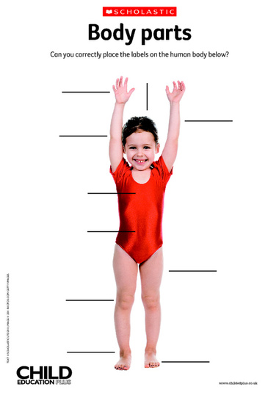

Lesson 4
3 .Drawing and naming the body parts separately e.g eyes,nose legs etc.
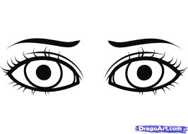 | 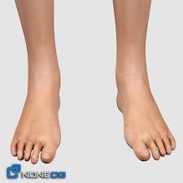 | 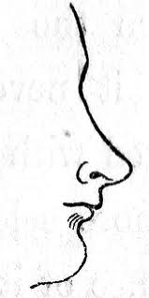

Ref. Pentagram book1 page 4.
Standard 1 CRE, page 1
WEEK 4
Lesson5

Uses of our body parts.
Legs are used for walking and playing football
Hands are used for writing
Mouth is used for eating and speaking
Nose is used for breathing and smelling
Ears are used for hearing
Eyes are used for seeing
Teeth are used for biting and chewing food
Tongue is used for tasting
Skin is used for feeling
Ref: Standard 1 CRE pg 1

Genesis 1:26-30
Lesson 6
How to keep my body parts clean.

_ Bathing our body daily.
_ Brushing our teeth.
_ Combing our hair.
_Cutting our nails short.
_Cutting our hair short.
_ Clean my nose.

Week5

Lesson7
Importance of keeping my body parts clean.

-To be healthy (avoid diseases).
_To look smart.
_To prevent tooth decay.
_To prevent bad body smell.

NB. When we keep our body parts clean, we make God happy.
Lesson 8
Senses and sense organs
Week6
Lesson9
Importance of personal hygiene

-To prevent skin diseases
-To look smart
-To prevent bad body smell

[Psalms 8:1-7]
Things used in personal hygiene

Sponge
Soap
Tooth brush
Tooth paste
Water
Basin
Comb
Towel

Razor blade
Activity:Draw any four things used in personal hygiene
WEEK: 7

Theme: Discovering God’s gift to me

Sub theme: People found at school.
Lesson 10
Naming people found at school.
Teachers, pupils/children cleaners, cooks, nurses, bursar, secretaries, guards ,parents, etc.
2. Importance/uses of these people at school.

Teachers --teach children.
Cooks _ cook and serve food.
Nurses _ treat school children.
Cleaners _ clean the school.
Bursar _ collect school money.
Secretaries _ type letters and exams.
Guards _ provide/give security for the school.
Friends _ play and share with us.

Ref. pentagram book 1 page 15 and 16
Ruth 1:1-12
Psalms 43:1
WEEK7
Lesson11
How I can help other people.

I fetch water for our neighbours.
I take care for the sick.
I wash the plates and cups.
I help my friend with a pencil.

Activity: Draw your self helping someone

I help my mother to carry a baby.
I help daddy to wash the car.
I help my parents to sweep the house.

WEEK 8

Lesson12
People found at home and those who visit us.

The gift of people at home.

Mother, father, brother, sister, uncle, aunt, nephew, grandmother, grandfather, niece.

I thank God for the gift of my parents, sisters and brothers, and other relatives.

Activity: Draw yourself with any two people at home.

How the people at home help us.
Parents:
Father :

-Heads the family

-He buys food

-He pays school fees

Mother

-Cooks food

-Cares for the young ones

-Grows crops

Children

-wash clothes

-sweep the compound

-fetch water

Question
As a child, what is your role at home?

WEEK 8
Lesson 14

Ways of respecting people.

Greeting people.

Listening to elder

- Using polite language e.g sorry, thank you, excuse me, please etc.
- Not using abusive language.
- Going to school daily.

N.B Discuss orally why parents/guardians need to be respected.

WEEK 9
Lesson15

Creation

Things created by God

- Plants
- Animals
- Stars
- Moon
- People
- Land

etc

God created all things in six days and rested on the seventh day.

- On the first day, God created light
- On the second day, God created the sky.
- On the third day, God created the earth, the sea, and the plants.
- On the fourth day, God created the sun, the moon, and the stars.
- On the fifth day, God created all the creatures which live in water and the birds.
- On the sixth day, God created all the animals on land domestic and wild then human beings to rule over all this

Activity: Draw and name any two things created by God on different days.
Lesson16

Uses of God’s creation.
Uses of animals:

- Some give us food, security, company, and transport.
- For study purposes/ we study about them.

N.B: We have to care for God’s creation.

Activity: Draw and name any three animals that are useful people

How do we care for domestic animals?

- By feeding them
- By treating the sic ones
- By loving them

Lesson 17

Uses of plants

Plants:

- Some plants give us food.
- Some plants give us fire wood and charcoal.
- Flowers are used for decoration.
- Some plants give us shade.
- We get building materials like timber, poles, sticks, etc from plants.
- We get local medicine from plants.
- We get timber for furniture from some plants
Activity
Draw and name any two plants which give us food

How do we care for the plants?

By watering them
By weeding
By thinning
By mulching

Ref. Pentagram book one page 22-23.
Lesson18

Other useful things created by God.

Sun, moon and stars

Importance of these things created by God

- The sun gives us light and warmth.
- The moon and stars give us light at night

2. Water
Uses of water

- For domestic use like cooking, washing, drinking, etc.
- Some animals live in water like fish, frogs, crocodiles, etc.
- Plants and animals need water for growth.

Activity: Draw and name three things which God created for light.

----------------- ------------------ -------------------

